Gamma News – Unfolding Here 2
February 2024

February Meeting Saturday, February 10, 2024 from 11:30-1:30
Margo Thayer’s home - 7215 W. Tara Ave, 702-222-9878
Activity: We will be sharing a few words about Great Women in our families.
Elections for 24-26 Officers
Rose of Recognition Selection
Nevada Reading Week
Theme: Embrace the Magic of Reading - March 4-March 8
Contact Karen to become a Volunteer Reader...
Margo is supplying an entrée – so bringing a side dish, dessert, or salad would be nice.
Basket provided by Joyce

Elections for 24-26 Officers
president, 1st vice-president, 2nd vice-president, secretary
If you are interested in serving in any of the offices, let Shannon and Karen know.
Shannon M. Koss s7koss@yahoo.com (702) 649-0088
Karen M. Laskowski lslkml@epix.net (570) 814-3351

March Meeting: Saturday March 16, 2024 – 11:30-1:30
Donna Harper’s home 760 Star Apple Lane (760) 224-5782
Presentation of Kids Activities in Vegas, and enjoy an Irish lunch.
Donna will supply basket

Founder’s Day
It was decided at the January meeting to hold the Founder’s Day Tea at The Queen of Hearts. It’s located in Henderson [2895 N Green Valley Pkwy Suite D]
Donna volunteered to contact them and make the arrangements [thank you Donna] as she had done it before. Thanks to her negotiating skills and the kindness of the owner, we will be receiving a $10 discount per person on the price.
Guests are Welcome!
DKG Founders, 5/4/24 @11 am
Afternoon Tea Booking, $45/person
(tax & gratuity included)
Quantity: 1pl, Traditional or Vegan Menu
Total: $45

You will need to register online directly with them. Confirmation will be sent once payment is complete. You may also call in if you prefer to pay by card over the phone.
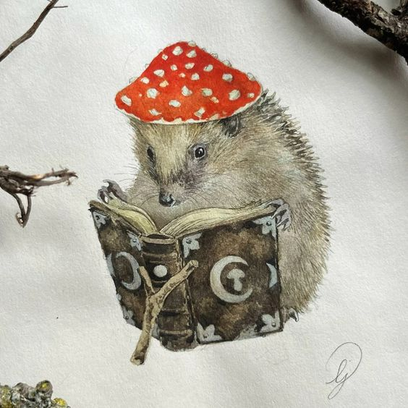
*If paying separately, please have your Guests reference the name & date of your party.
Checkout & Pay:
https://square.link/u/QiH0HmiP DKG is our code.
Donna will be putting together a flyer for us to send to Epsilon.

Trivial Pursuit #5 - Detective Shows

What amateur detective did Agatha Christie first create in the 1930 novel “The Murder at the Vicarage”?
A Sam Spade
B Philip Marlowe
C Sherlock Holmes
D Miss Marple
What is the name of Sherlock Holmes’ brilliant archnemesis?
A James Moriarty
B Mycroft
C John Watson
D Mrs. Hudson
What was the name of the L.A police detective character in the ’50s and ’60s TV series “Dragnet”?
A Joe Mannix
B Pete Molloy
C Robert Ironside
D Joe Friday
Who is the credited author of the Nancy Drew mystery series of books?
A Enola Holmes
B Louise Fitzhugh
C Franklin W. Dixon
D Carolyn Keene
Magnum P.I. solves crimes in what state?
A New York
B California
C Hawaii
D Florida
What tiny town did mystery-writer-turned-crime-solver Jessica Fletcher call home in “Murder, She Wrote”?
A Cabot Cove
B Mayberry
C Knot’s Landing
D Petticoat Junction
What classic ’60s comedy star played crime-solving defense attorney Ben Matlock?
A Dick Van Dyke
B Andy Griffith
C Larry Hagman
D Lee Majors
Which future James Bond got his big break in the ’80s TV hit “Remington Steele” as a con man pretending to be a licensed private investigator?
A Pierce Brosnan
B Timothy Dalton
C Daniel Craig
D Sean Connery
What NYPD detectives, played by Sharon Gless and Tyne Daly, are widely credited as TV’s first all-female crime-fighting duo?
A “Starsky & Hutch”
B “Rizzoli & Isles”
C “Cagney & Lacey”
D “Simon & Simon

